2.2 Legislative Branch

SSCG8e: Explain the steps in the legislative process.
A bill, which is a proposed law, must originate in the House of Representatives or the Senate, except for revenue bills which MUST originate in the House.

Steps in the legislative process: (If a bill originates in the Senate, the steps below are reversed for House and Senate).
- The bill is drafted (anyone can draft a bill – members of Congress, the President, outside groups)
- Introduced in the House - a House of Representatives member introduces the bill (only members of the House or Senate can introduce bills).
- The Speaker of the House sends the bill to a committee.
- Committee Action – most bills die here, but if the bill is passed, it goes to the Rules Committee.
- Rules Committee – the bill is assigned a time for debate in the House (only the House has a Rules Committee).
- Floor Action – the bill is debated, and amended, if necessary. If a majority of House members approve the bill, it goes to the Senate.
- Introduced in the Senate – a senator introduces the bill, and the bill is assigned to a committee.
- Committee Action – if the committee majority votes for the bill, it goes for debate in the Senate as a whole.
- Bill Called Up – the Senate Majority Floor Leader decides when the bill will go up for debate.
- Floor Action – the bill is debated, and amendments may be made. If the bill passes the Senate with a majority vote, it is sent back to the House.
- Conference Committee – if the House rejects any changes made by the Senate, it goes to a conference committee, which is comprised of members from both the House and the Senate. They work out a compromise.
- Vote on Compromise – both the House and the Senate must approve the bill as amended by the conference committee. If approved by a majority vote in both houses of Congress, the bill is sent to the President.
- Presidential Action – the President may sign, or approve, the bill or veto (reject) the bill. If the President signs the bill, becomes law.
- Vote to Override – if the President vetoes the bill, it can still be approved by a two-thirds majority in both houses to become law.
Other terms that students should be familiar with regarding the legislative process include:
Rider – a provision not likely to pass on its own merit that is attached to a bill that is certain to pass.
Discharge petition – this petition enables members of either house to force a bill that has remained in committee for 30 days or longer onto the floor for consideration.
Quorum – a majority of the membership that must be present in chambers to conduct business.
Engrossed – the bill is engrossed when it is printed in its’ final form.
Filibuster – essentially this is the attempt to ‘talk a bill to death’. It is a stalling tactic that is used by a minority of senators seeks to delay or prevent Senate action on a matter. A filibuster can ONLY be used in the Senate.
Cloture – a Senate rule used to limit debate. At least three-fifths of the senate, or 60 members, must vote to invoke cloture.
Veto – when the President refused to sign a bill into law.
Pocket veto – if Congress adjourns its’ session within ten days of submitting a bill to the President, and the President does not act, the bill dies.

SSCG8f: Explain the functions of various leadership positions and committees within the legislature.
*The Speaker of the House is the most important position in Congress. The Speaker is the elected, presiding officer of the House of Representatives. The Speaker is chosen from the majority party in the House and is typically the longest serving House member. The Speaker’s powers revolve around two primary duties: 1) preside over the House, and 2) maintain order. The Speaker presides over most sessions of Congress. No member of the House may speak unless he or she is recognized by the Speaker and given permission to speak. Other duties include: interprets and applies the rules of the House, refers bills to committees, rules on points of order, puts motions to a vote, and names the members of all select and conference committees. The Speaker must sign all resolutions and bills passed by the House. The Speaker may vote, but typically only does so in the event of a tie.
*The President of the Senate is always the Vice President of the United States and is the Senate’s presiding officer. Unlike the Speaker of the House, the President of the Senate is not an elected member of Congress and may not even be a member of the majority party in the Senate. The President of the Senate does have the following powers: recognize members who want to speak, put measures to a vote, and vote ONLY in the event of a tie. In addition, the President of the Senate may NOT debate a bill.
*The President Pro Tempore is the presiding officer of the Senate in the Vice President’s absence. The President Pro Tempore is elected by the members of the Senate and is always a member of the majority party. Like the Speaker, the President Pro Tempore is typically the longest serving member of the Senate’s majority party.
*Both the House and the Senate have a majority leader. They are chosen by party members within their respective houses of Congress from the majority party. Their role is to carry out decisions of the party caucuses, steer floor action and votes to their party’s advantage, and serve as the chief spokesperson for his or her party. The minority leaders serve the same roles as the majority floor leaders, but they are chosen from the minority party in each house of Congress.
*Whips are essentially assistant floor leaders, and both the majority party and the minority party of both the House and the Senate have whips who are appointed by their party colleagues. The whips are a liaison between the party’s leadership and the other members. The primary duty of the whip is to keep track of the number of votes on measures that are being debated and voted on in both the House and the Senate. The whips also make sure that all party members are present in chambers for votes.
*Standing committees are permanent committees in the both the House and the Senate. Similar bills are sent to various standing committees. The House and Senate have their own standing committees. The House of Representatives currently has 20 standing committees, and the Senate has 16 standing committees.
*Select committees are sometimes referred to as special committees. They are set up for specific purpose and usually for a limited period of time. The Speaker and the President of the Senate assign the members to select committees. Select committees are formed to investigate a current matter.
*Joint committees are composed of members of both the House and the Senate. Some joint committees are select committees and some are permanent.
*A conference committee is a temporary, joint committee that is organized to iron out differences in the versions of a bill from the House and the Senate. The final bills from both the House and Senate must be identical before they can be sent on to the President. Once a compromise is reached, the conference committee disbands.

SSCG8g: Analyze the positive and negative role lobbyists play in the legislative process

*Lobbying includes the activities by which group pressures are brought to bear on the legislative process and legislators. Lobbyists, those individuals who lobby, are usually connected to special interest groups.
The lobbyists ‘campaign’ to have public policy approved that represents the special interests of the group they work for. For example, the NRA (National Rifle Association) employs lobbyists to persuade legislators to pass bills and enforce public policy that supports their interests in gun control. Companies who manufacture guns, ammunition, and related products obviously want laws that support the second amendment right to bear arms.
There are positive aspects of lobbying. Lobbyists are usually very knowledgeable on the issue they represent. They can educate members of both the House and the Senate on the issues at hand to better inform legislators. Lobbyists represent a much wider group of people who share similar interests and act as the spokesperson for those common interests. Lobbyists can assist legislators in drafting legislation and including accurate, up-to-date information on issues of public policy.
There is often a negative connotation associated with the word lobbyist. In earlier times, lobbying brought forth images of bribery and the use of unethical practices. Regulations have removed the abuses lobbyists used in past legislative processes. One negative aspect of lobbying is that the special interest groups that have the most money are often the groups that have legislation drafted and passed in their favor. There may be important and valid issues that need addressed from a public policy perspective, but if it is grassroots effort with little money, their interests may go unnoticed at the national and state levels.

Document 3
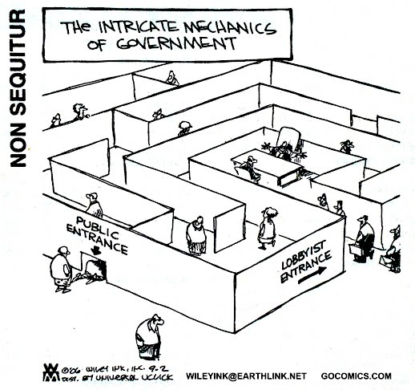
Document 4
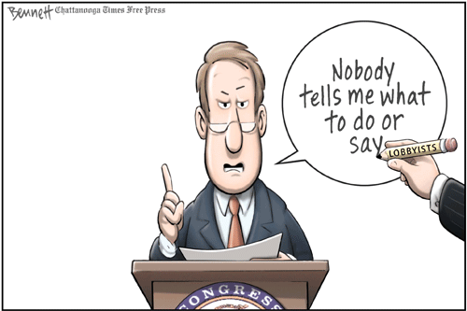

SSCG9: Explain the impeachment and removal process and its use for federal officials as defined in the U.S. Constitution.

*Impeachment is the formal accusation of wrongdoing or misconduct by the President, Vice President, and all civil officers of the United States. The Constitution provides for the impeachment of officials at the federal level. Article II, Section 4 states “the President, Vice President, and all civil officers of the United States, shall be removed from office on impeachment for, and conviction of, treason, bribery, or other high crimes and misdemeanors” to impeach an official means to bring charges against that official.
*The House of Representatives has the sole power to accuse and bring the charges in impeachment. Impeachment requires a majority vote in the House. It is the Senate’s job to try, or judge, impeachment cases. A conviction requires a two-thirds vote in the Senate. The penalty for conviction is removal from office. If a federal official is impeached and removed from office, he or she may still face criminal charges and may face a trial in the regular court system.
*Only two presidents have been impeached by the House of Representatives, and in both cases, the Senate voted to acquit, or find not guilty. Andrew Johnson was impeached in 1868, and Bill Clinton was impeached in 1998. A third president, Richard Nixon, would have most certainly been impeached in 1974; however he resigned before the impeachment charges were brought against him by the House of Representatives.

