4.1 The Judicial Branch

SSCG13: Demonstrate knowledge of the operation of the judicial branch of government.

The judicial branch is the third co-equal branch of our federal government. It includes the Supreme Court, the entire federal court system and the judges that serve in it. The Supreme Court is the highest federal court in the United States and was established in the Constitution in Article III. There are nine Justices on the Supreme Court; there are eight associate justices and one chief justice.

SSCG13a: Describe the selection and approval process for federal judges.
Federal judgeship appointments and Supreme Court Justice appointments are for life, and because these judges serve lifetime appointments, their decisions can have significant impacts that last beyond one election cycle. There are basically nine steps for federal judicial nominations (from vacancy to confirmation):
- A vacancy occurs when a judge dies, retires, or decides to step down.
- The White House consults the Senators who represent the state in which the vacancy has occurred to get recommendations for potential candidates to fill the vacancy.
- Potential candidates are thoroughly vetted; background checks are extensive. The Senate Judiciary Committee* requires the candidates to complete a detailed questionnaire. The candidate’s legal qualifications, past employment history, decisions on cases, tax compliance history, reputation with legal colleagues and community members, medical examination results, and criminal background history are all part of this vetting process.
- Once a nomination is made by the President, the process moves to the Senate Judiciary Committee members.
- The Senate Judiciary Committee conducts a hearing. This is the time when all committee members are given the opportunity to ask the nominee questions.
- The Senate Judiciary Committee votes. Once the nominee is favorably voted out of the committee, with a majority vote, the nomination is forwarded to the Senate floor for consideration by the entire Senate.
- The Senate majority leader schedules a full vote in the U.S. Senate and debate ensues.
- The nominee is confirmed if he or she receives a majority of the votes by the Senators.
- Lifetime appointment begins after the President signs the nominee’s commission.
*This entire process can take weeks or months from beginning to end.
*The Senate Judiciary Committee is a standing committee in the Senate currently comprised of 20 members. This committee conducts hearings prior to Senate votes on the confirmation of federal judges, including Supreme Court Justices, who are nominated for the positions by the President.

Most federal judges are drawn from the ranks of leading attorneys, legal scholars, law school professors, and State court judges. Political party is important in this process; the President typically chooses candidates from his or her own political party. The President also looks for candidates who share similar views on economic, social, and legal issues. The concepts of judicial activism and judicial restraint play a role in the decision-making process. Federal judges can only be removed through impeachment. They are given lifetime appointments to ensure the independence of the federal judiciary and reduce the chances of decisions based on politics or political pressures.
SSCG13b: Explain the jurisdiction of the Supreme Court, federal courts and the state courts.
Jurisdiction is defined as the authority of a court to hear (try and decide) a case. Generally there are two types of jurisdiction, original and appellate. Original jurisdiction is the court where a case is first heard. Appellate jurisdiction is when a court hears a case on appeal from a lower court. The higher court, or appellate court, may uphold or overrule the decision of the lower court. Courts of appeals only have appellate jurisdiction.
The Supreme Court is known as the court of last resort. A decision issued by the Supreme Court cannot be appealed. The Supreme Court has both original and appellate jurisdiction. The court has original jurisdiction in cases of suits between states or cases involving ambassadors or public ministers. It has appellate jurisdiction on almost any other case on appeal that involves a point of constitutional and/or federal law
Federal courts have limited jurisdiction and may only hear cases authorized by the U.S. Constitution or federal statutes. The federal courts have three levels: district courts (the trial courts), circuit courts (first level of appeals), and the Supreme Court. There are 94 district courts, 13 circuit courts of appeal, and one Supreme Court in the United States.
State courts are courts of general jurisdiction, meaning that they hear cases that not specifically selected for federal courts. Additionally, state courts interpret state laws.
Exclusive jurisdiction means that a case can ONLY be heard in a federal court. Examples of cases that fall under exclusive jurisdiction include: cases involving an ambassador or other official of a foreign government, the trial of a person charged with a federal crime, a suit involving the infringement of a patent or a copyright, or any other case involving a matter arising out of an act of Congress. Concurrent jurisdiction is when a case can be heard in either a state court or a federal court. Concurrent jurisdiction means that the state and federal courts share the power to hear a case. An example of this type of case would include disputes between citizens of different states if the amount of money at issue is $75,000 or greater.

The following illustrates the hierarchy of the United States court system:

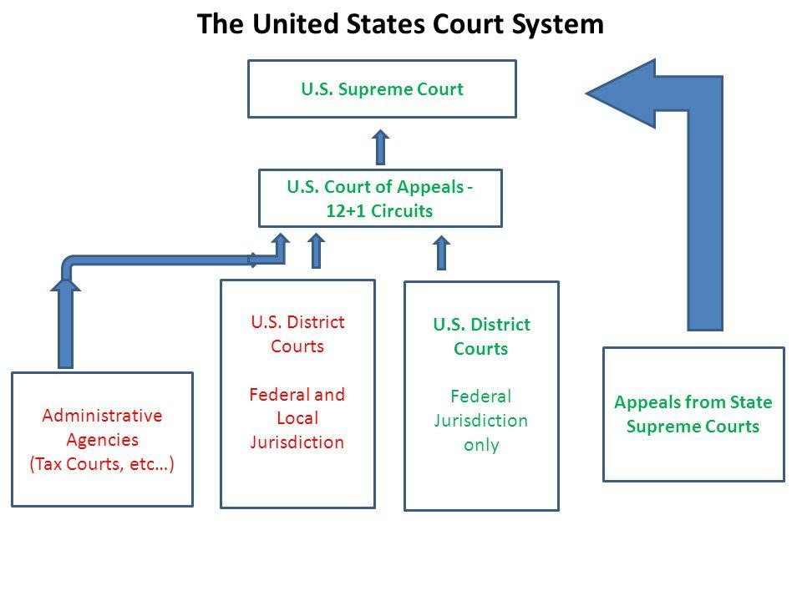

SSCG13c: Examine how John Marshall established judicial review through his opinion in Marbury v. Madison and relate its impact.
Judicial review is the review by the U.S. Supreme Court of constitutional validity of a certain legislative act. Judicial review was established by the landmark Supreme Court case of Marbury v. Madison 1803.
In the case of Marbury v. Madison 1803, the concept of judicial review was established. The case arose after the elections of 1800. Thomas Jefferson, a Democratic-Republican, won the presidency and control of both houses of Congress. The outgoing party, the Federalists, made last minute attempts to fill the judiciary with loyal party members. Congress created several new federal judgeships, and outgoing President John Adams filled those new positions with loyal Federalists.
William Marbury was appointed to one of those positions as a Justice of the Peace in Washington D.C. The Senate confirmed all of the appointments made by Adams. All of these confirmations took place late at night on the last day of President Adams’ presidency. The next day, President Thomas Jefferson took office and realized that several of the last minute appointments had not been hand-delivered to the appointees. Jefferson was angry at Adams’ for the attempt to pack the judicial system with Federalists. He instructed his new Secretary of State, James Madison, not to deliver the appointments. William Marbury went to the Supreme Court seeking the court to issue a writ of mandamus to order the delivery of his appointment, since it was made before Thomas Jefferson took office. Marbury based his suit on the Judiciary Act of 1789, in which Congress created the federal court system.
John Marshall was the Chief Justice of the Supreme Court, and he refused Marbury’s request to issue the writ of mandamus, and Marbury was denied his commission as Justice of the Peace. The original jurisdiction of the Supreme Court only extends to cases involving disputes between states or issues involving ambassadors or public ministers. Marshall stated that Congress had overstepped the boundaries by stating that Marbury’s case fell under the original jurisdiction of the Supreme Court. Marshall’s opinion was based on three propositions: 1) the Constitution is the supreme law of the land, 2) all legislative acts and other actions of the government are subordinate to the supreme law of the land and cannot conflict with it, and 3) Supreme Court judges are sworn to enforce the Constitution and must refuse to enforce any government action that conflicts with the Constitution.
The impact of Marbury v. Madison 1803 is that the Supreme Court can declare acts of Congress unconstitutional, if those acts are in conflict with the Constitution. This laid the foundation for the judicial branch’s right to declare what is or is not constitutional and for the Supreme Court to uphold the Constitution as the supreme law of the land.

SSCG13d: Describe how the Supreme Court selects and decides cases.
The Supreme Court typically receives around 7,000 requests each year. On average, they choose to hear arguments on 80 cases and decide another 50 cases without hearing arguments. The cases chosen by the Supreme Court usually address issues of constitutionality or federal law. To decide which of the 7,000 cases that the court will hear, the Justices first apply what is called the ‘rule of four’. The ‘rule of four’ states that at least four of the nine justices must agree to hear a case in order for that case to be placed on the court’s docket, or calendar. If they agree to hear a given case, the petition for certiorari is granted. A writ of certiorari, which is an order by a lower court to send up the record in a given case for review by the Supreme Court
The Supreme Court sits from the first Monday in October to sometime in late June or early July. Once the Supreme Court accepts a case, it sets a date on which the case will be held. The justices consider cases on two-week cycles. They hear oral arguments for two weeks and then recess for two weeks to consider those cases and handle other court business. The oral arguments by the lawyers are typically limited to 30 minutes per side. Prior to oral arguments, the lawyers prepare briefs, which are written documents filed with the court that outline detailed statements and arguments that support each side of the case. When the justices meet to decide cases, they are said to be in conference. The Chief Justice presides over the conferences. The Chief Justice speaks first, and then each associate justice summarizes his or her views. The presentations are made in the order of seniority. After discussion and debate, the justices vote on the case. A quorum of six justices is required to hear a case, and decisions are based on majority votes.
The court’s opinion on a case is known as the majority opinion. It is officially called the opinion of the court and announces the court’s decision in a case. The opinion sets out the reasoning for the decision. If the Chief Justice is in the majority on a case, he assigns the writing of the court’s opinion. Typically, the opinions of the justices are based on precedents. Precedents are past examples to be followed in similar cases. The majority opinions serve as precedents for future cases.
Sometimes justices may decide to write concurring opinions. This is when one or more of the justices agree with the court’s opinion and want to add or emphasize points not made in the majority opinion. Dissenting opinions are written by those justices who do not agree with the court’s majority decision. This is also known as the minority opinion.

SSCG13e: Compare the philosophies of judicial activism and judicial restraint and provide relevant examples (e.g., marriage, 2nd Amendment, death penalty, etc.).
There are two major philosophies regarding how judges should rule on controversial issue. Those two philosophies are judicial activism and judicial restraint. Judicial Activism refers to judicial rulings that interpret the constitution broadly whereas Judicial Restraint is the idea that judges should limit themselves to original thinking of the founders when making decisions. Proponents of judicial activism argue that that the Founding Fathers could not possibly include every scenario, particularly for events that may arise over 200 years after the ratification of the Constitution. Conversely proponents of judicial restraint would argue that activist judges are making decision based on their beliefs and not what the Constitution says.
Several recent cases have highlighted the differences between judicial activism and restraint. The recent controversial issue of same-sex marriage was brought before the Supreme Court, and in July, 2015, the Supreme Court made a ruling that the Constitution did not address marriage. Therefore, same-sex marriage was declared legal in the United States by the Supreme Court. Supporters of the decision have stated that although marriage is not explicitly addressed in the Constitution, the 14th Amendment protects the rights of all Americans to enjoy liberty. The argument is. Critics state that this decision represents judicial activism and that justices have used personal opinions and political pressures to allow same-sex marriage.
Additionally, the 2nd Amendment provides the right for all Americans to bear arms. In the wake of recent mass shootings in Texas and Los Vegas, Judicial restraint proponents argue that law-abiding American citizens should have the right to bear arms, while judicial activists might argue that in cases of gun violence, the government should be allowed to redefine the terms under which Americans have the right to bear arms.
The death penalty has long been the subject of debate between judicial activists and those supporting judicial restraint. The supporters of judicial restraint might argue that even though the 8th Amendment prohibits cruel and unusual punishment, the 5th Amendment provides that no person shall be deprived of life without due process of law. Therefore, if an individual is indicted by a grand jury, is found guilty of a capital crime by one’s peers, and is provided due process of law, then the death penalty can be upheld. Meanwhile, judicial activists may argue that the 8th Amendment’s ban on cruel and unusual punishment is enough to make this type of punishment unconstitutional and may insert personal and political opinions as to why consideration of the 8th Amendment without consideration of the 5th Amendment is justified.

